Practical 9: Google Form Quiz with Timer

Aim

To create a quiz with automatic grading and time limit.

Objectives
• To automate quiz assessment
• To use time limit add-on

Materials Required
• Google Forms
• Timer add-on

Procedure
1. Create Google Form – Open Google Forms and start a new blank form to set up the structure of your activity.

2. Convert to quiz – Enable “Make this a quiz” in the settings so you can assign points and correct answers.

3. Add 5 MCQs + 1 short answer – Insert five multiple-choice questions and one short-answer question, customizing options and points.

4. Enable 1-response limit – Turn on “Limit to 1 response” so each user can submit the form only once.

5. Shuffle questions – Activate the shuffle feature to randomize the order of questions for every respondent.

6. Add timer add-on – Install a timer add-on from the Add-ons menu to set and control the quiz duration.

7. Send link – Use the “Send” button to generate and share the form link with participants.

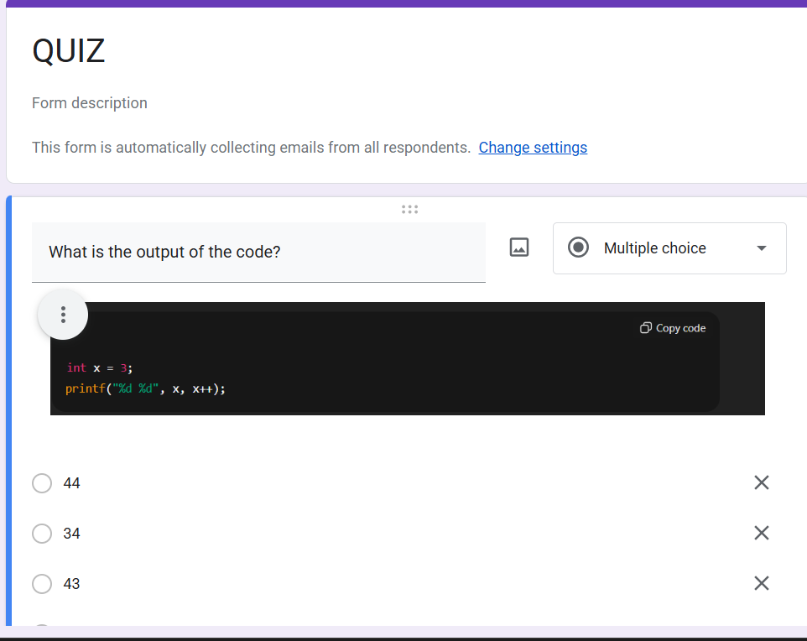

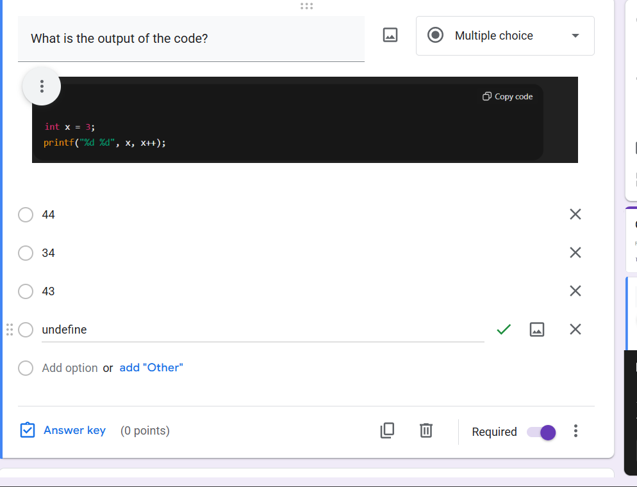

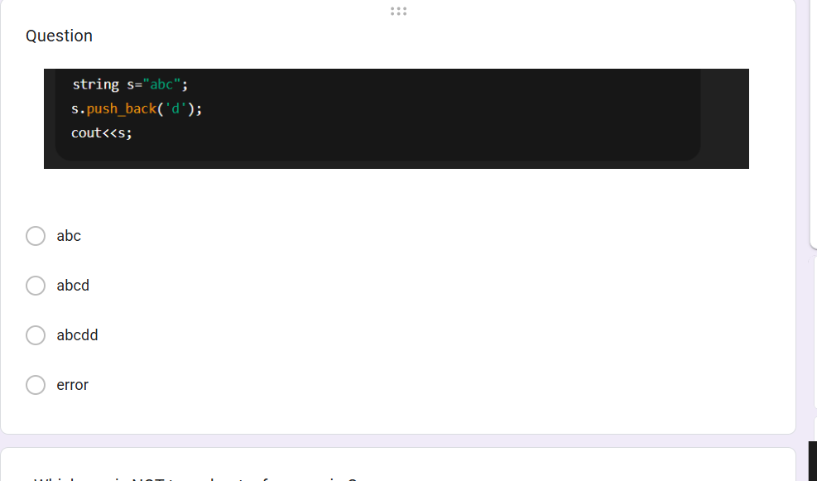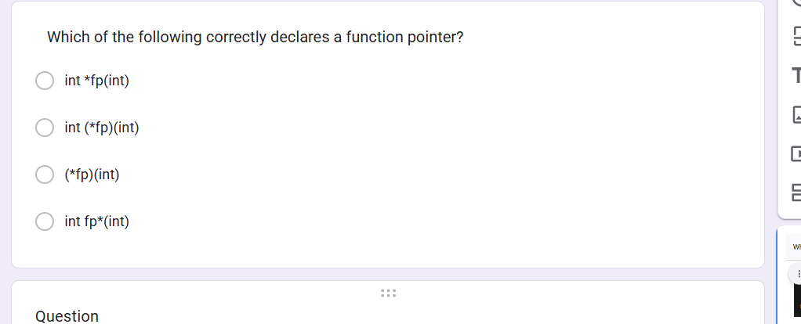

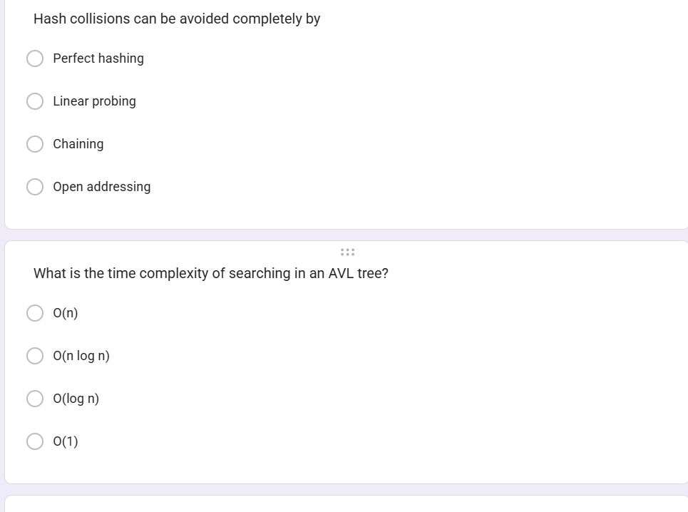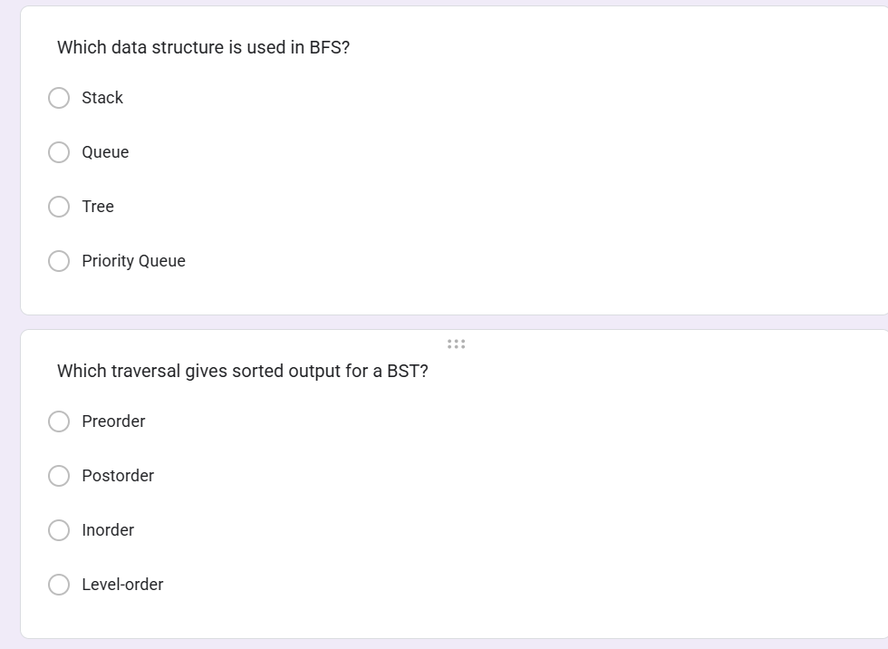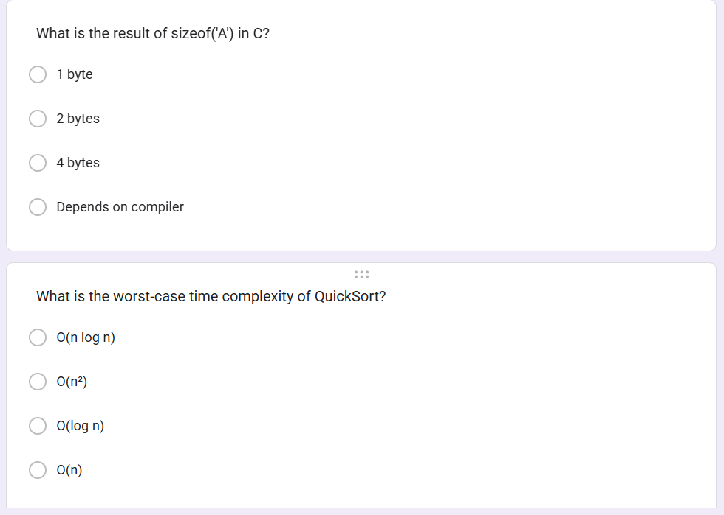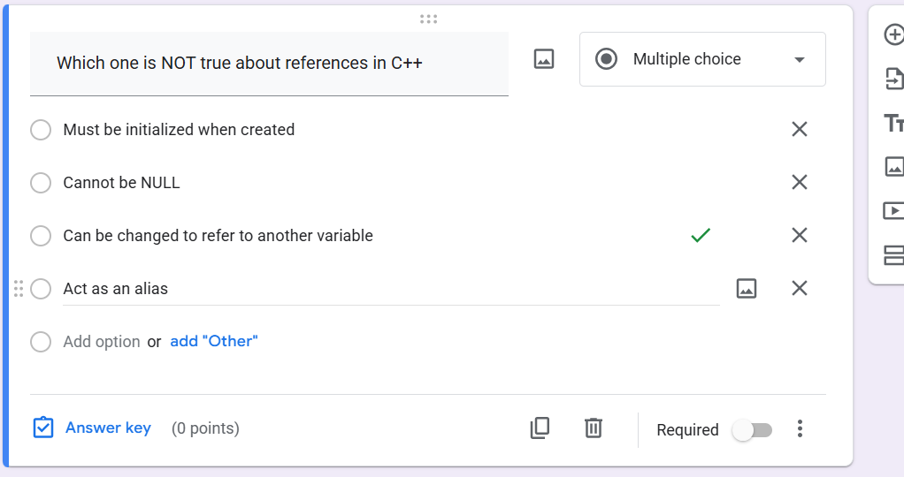

RESPONSE:

